ANU update from Julia Miller
PARADISEC users’ guide:
I am putting the finishing touches on a new users’ guide for archiving with PARADISEC. The guide offers suggestions as to what a collection might look like, how to organize items, file-naming conventions, work-flow for file transfer, and specific instructions for archiving video, FLEx and Toolbox files.

Archiving video:
I am finalizing the process by which we archive video, including contracting out all video transcoding to DAMsmart!. They have provided us with high quality, archival digitized versions of legacy video tapes over the past few years. They are keen to continue to offer us quality service with our born-digital video files. Video cameras record raw video formats with various aspect-ratios, frames per second, and different specifications for audio. None of the files are truly archival in these brand-specific, proprietary formats, and in addition to being very tricky to transcode from a raw .mts format, to a usable .mov or .avi, etc., all raw files are too large for a researcher to easily use; I have decided it is best at this point to contract this part of the workflow out to video professionals. We will receive archival files and we can return compressed, working-files to the depositors, all generated at the same time, eliminating the risk of errors due to re-creating and transferring multiple transcoded files.

Transfer of multiple and large files:
I am currently in talks with AARNet (Australian Academic and Research Network) and Cloudstor to devise a file-sharing, file-transfer plan that will allow a depositor to easily transfer files to a centralized, shared drive for distribution directly to PARADISEC (archive-ready audio) or to DAMsmart! (video encoding). Below is a working model of the workflow proposed for CoEDL members, and can easily be extended to include most, if not all general PARADISEC depositors. For those not affiliated with an Australian institution for an AAF (Australian Access Federation) shibboleth log-in, there will be a VPN (virtual private network) log-in available, though a hi-speed internet connection will likely not be available for those not connected to AARNet. We can still accept physical hard-drives posted to us for situations where it is necessary.

RA hire:
I will be hiring an RA to help with ongoing/upcoming digitization projects, including CoEDL requests from AIATSIS to digitize tapes in their collection that have yet to be digitized. Still t.b.d. if we will also archive this material with PARADISEC, or just return original and digital copies for AIATSIS to archive. The RA will also help inventory collections that we receive at ANU. For example, Darrell Tryon has a collection that has been accessioned, but not cataloged with the ANU Archives. This collections includes his papers and notes. The RA would inventory this and we can determine if there are any field notes or journals that complement the tapes we are currently digitizing in Melbourne for the Tryon collection (DT1). We would then digitize those and archive them in DT1 along with the audio.

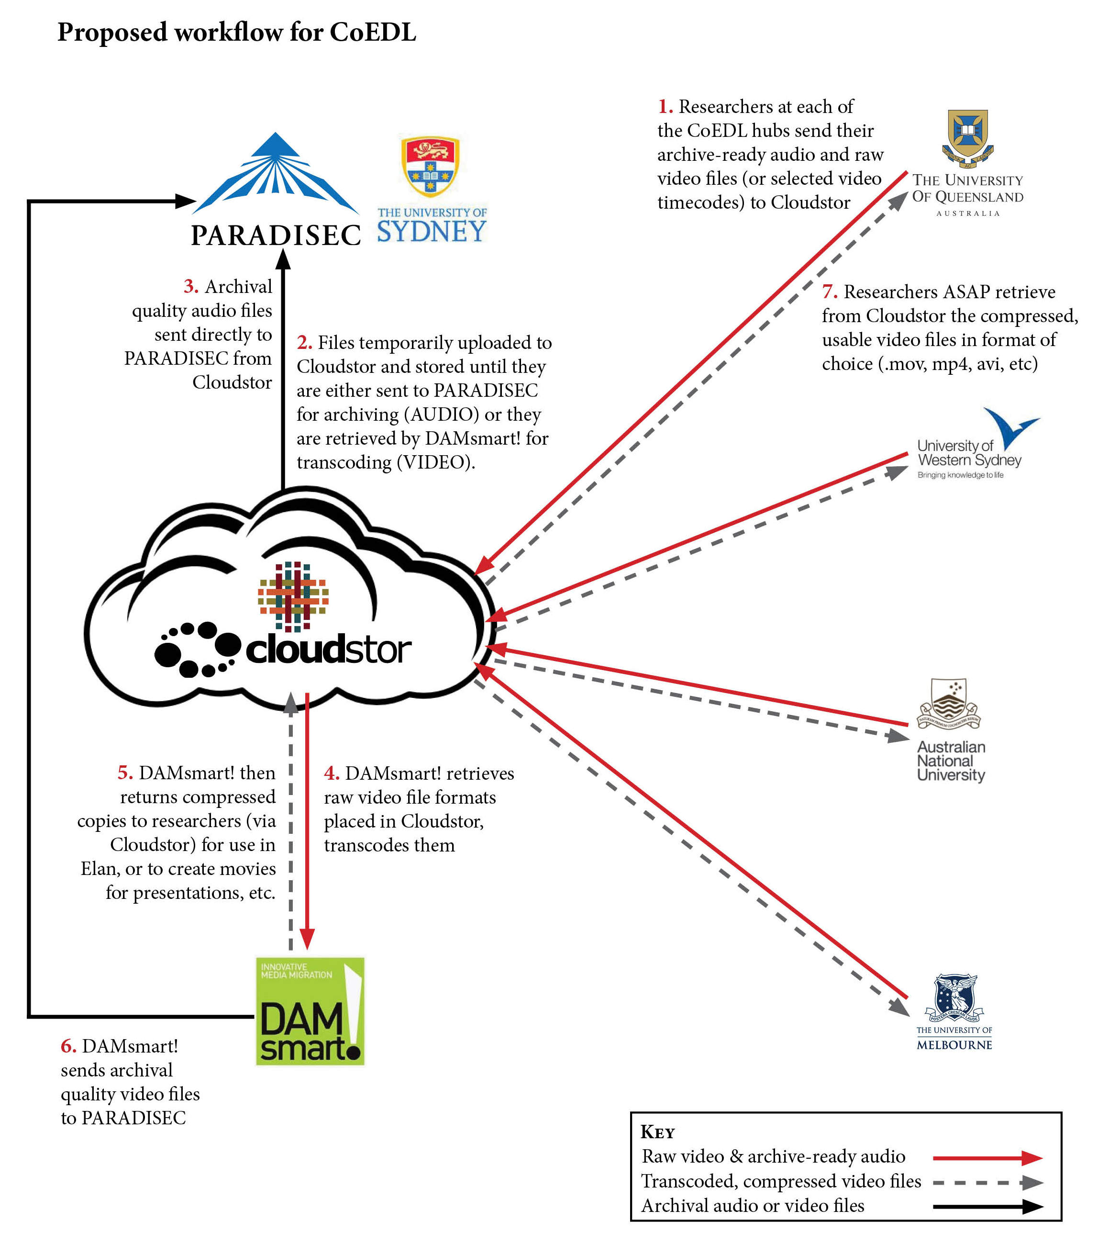

Collections:
Mary Ayres (MA1)
All 20 tapes have been digitized, after repair work was done to 75% of the tapes. Photographs of the metadata (tape boxes) and the audio files will be uploaded and the catalog enriched with complete metadata.

Stephen Wurm (saw3):
This work will continue when we hire an RA. There will be well over 100 more items to add.

Don Laycock (DL2):
Images taken of Don Laycock’s notebooks are still being added to the collection, and the metadata in the catalog is being enriched.

SocCog:
Another researcher (Diana Forker) has added her files to the Social Cognition collection: 43 content files

LSNG collections:
I will be adding to Nick Evans’ collection (LSNG02) multiple languages of the Southern New Guinea Languages project, as well as encouraging others project members to begin adding their material to the collections. This will be a slow process, as many of the project members are also working on their PhDs.

Workshop:
I ran a two-day workshop (6 hours in total) to train researchers in the use of field recording equipment. As CoEDL is furnishing equipment to researchers to collect material that will be archived in PARADISEC, I though it a good idea to train people in some best practices for recording techniques. I introduced researchers to what equipment we have been using at ANU (recorders, microphones as well as a selection of elicitation tools) and what other options people could utilize. I will be putting all recordings (both video and audio) and other useful information online for the other CoEDL nodes to access. I would encourage all nodes to offer training in the use and care of field equipment, as well as to communicate with other nodes as to what their thoughts are on specific technology or techniques.

Equipment:
I will be setting up 2 large workstations here at ANU for use by researchers to further process their videos for use in Elan, subtitled community materials, or for presentations. These computers (1 Mac, 1 PC) will also be used for PARADISEC depositors to upload their files to Cloudstor for archiving. Eventually, if we develop APIs with Alveo for analytical interactions with data in PARADISEC, these could be used for those tasks as well. I will report to the other CoEDL nodes the specifications and planned uses of these computers so that they might devise their own “PARADISEC portal” and multi-user workstations. I look forward to other suggestions of use as well.

