Metadata Instructions
Things to do before you are able to submit metadata:
Create a Collection in the PARADISEC archive (see Getting started with PARADISEC)
Organise your files to determine how many items you need to create in your collection catalog. For example, an item can be understood to be a recording event. All files associated with that event (.mts, .wav, .eaf, etc.) can be archived under that item (see Getting started with PARADISEC)
Name your files, following PARADISEC naming conventions: File Naming for PARADISEC archiving
Metadata records contain descriptions or attributes about a given resource. Essentially, metadata answers questions such as WHO, WHAT, WHEN, WHERE, HOW and WHY about your files. This information will help you and other researchers find your materials. The more details you provide, the easier that process will be. PARADISEC offers 3 methods for you to add metadata to the catalog. This guide offers a brief overview of two of them, with links to follow-up on a third option (ExSite9) should you choose to do so.

Minimal Metadata Sheet
The Minimal Metadata Sheet allows you to create a bulk set of items for your collection, requiring very few mandatory fields. It is the easiest and fastest way to populate your collection with items. As you can see in the image of the spreadsheet, there is a small number of fields to fill in: 4 fields to describe your collection, 7 fields for each item. NOTE: In order for the batch upload of metadata to work, you must not change the structure of the spreadsheet.
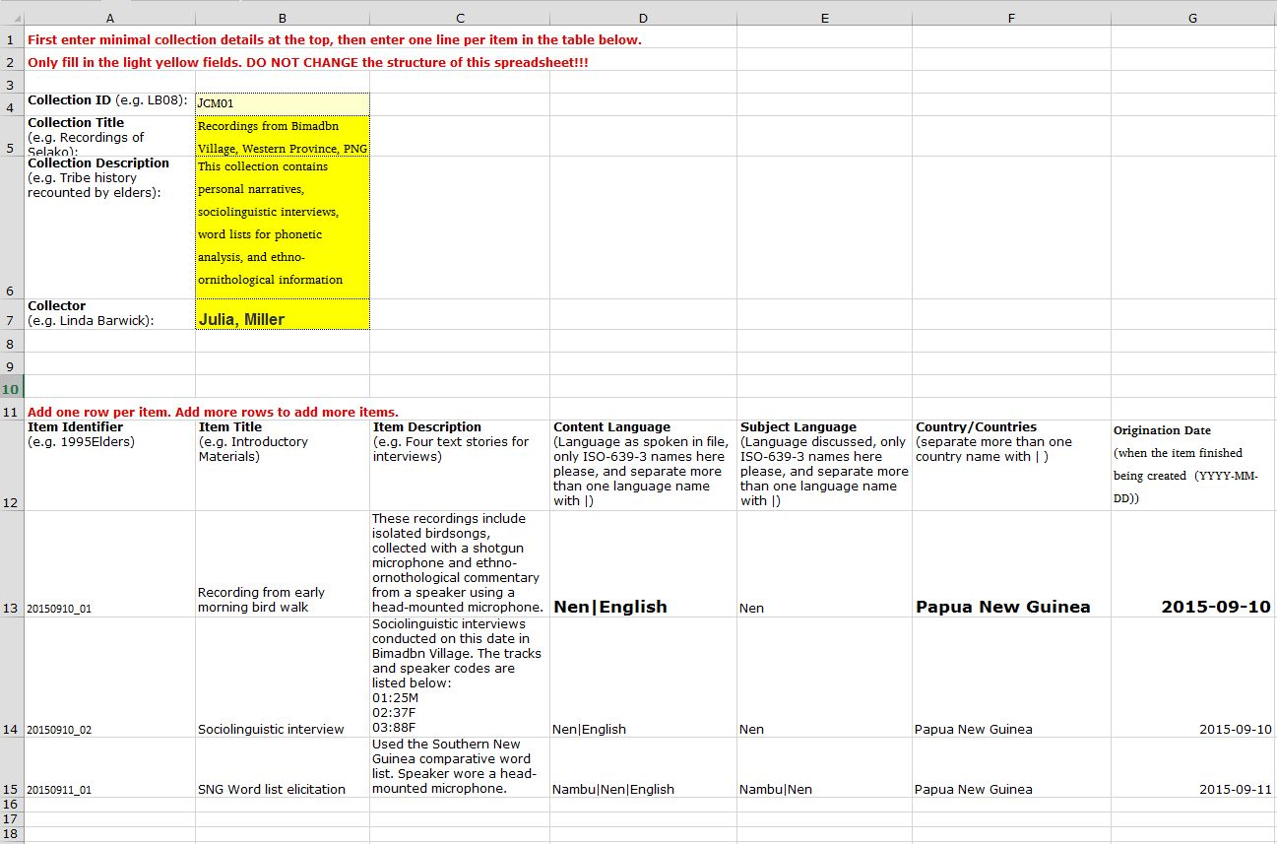
2
4
3
1

There are 4 quirky features of the minimal metadata spreadsheet at this time:
- You need to type your name as First, Last
- You must use the language name as it is found in the PARADISEC catalog, based upon those found in Ethnologue (http://www.ethnologue.com/), and NOT the 3-letter ISO codes. Also, if you have more than one language you’d like to list, you must use a pipe ( | ) to separate the languages, without any spaces.
- You must enter the name of the language in full, as it is found in Ethnologue.
- The year must be of the ISO shape YYYY-MM-DD, including the hyphens.
If your language does not have a code in Ethnologue, chances are we won’t have it listed in PARADISEC yet. Contact PARADISEC Administration (admin@paradisec.org.au) if this is the case and we will try to address this issue.
Once you have completed filling out your spreadsheet, send it to PARADISEC to upload into the catalog on your behalf. Once you can see items in your collection, you can then enrich the metadata of each item directly in the catalog.

Directly edit metadata in the PARADISEC catalog:
Another way to create an item in your collection, other than via the batch process of the spreadsheet upload, is by entering information directly into the catalog. Go to your collector’s dashboard, then click on the Add new item button:
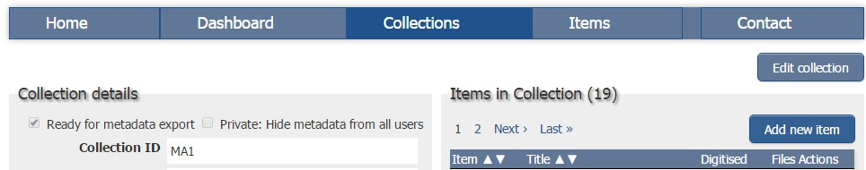
If you want to enrich the metadata of items already in the catalog, you can just go to an item in your collection and click on the Edit Item button:
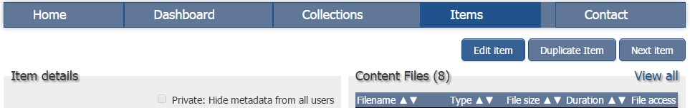
When you have finished adding metadata to your items, you must tick the box that says Ready for metadata export:
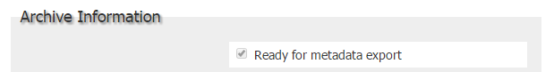

ExSite9
If you are interested in trying out the Exsite9 program for metadata editing, you can download it from the GitHub site (https://github.com/IntersectAustralia/exsite9/wiki/Install-packages). Instructions for use can be found in the Archiving Workflow Guide, as well as the following links:
- http://paradisec.org.au/PARADISEC-ExSite9guidance.pdf
- https://github.com/IntersectAustralia/exsite9/wiki/User-Manual

