Data storage

Portable hard drives
Portable hard drives are clearly meant to be a temporary storage option, as they can become damaged and unusable for seemingly innocuous reasons. They are great for use in the field, for transferring large amounts of files, or unwieldy-sized files, or as a back-up storage system (never as a primary storage).
ExFAT is an ideal file system for formatting your hard drives. This way, the drive will work with both PC and Mac platforms and there is no file-size limit for transfer.
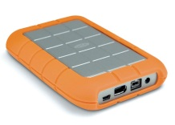The Rugged Lacie model is a solid, dependable choice. To get it ready before you begin putting files on it, I suggest following these steps to format it correctly:
- Use the accompanying Lacie software to format the hard drive. There is a slider that you can select to decide the percentage of FAT vs NFTS or HFS+ formatted partitioned drive. Slide it all the way to 100% FAT format. Then finish the formatting.
- You now need to create an ExFAT file system to allow you to connect to both Mac and PC without any file size restrictions:
- On a PC, use Windows explorer to re-format the drive. To do this just find the drive on your computer, right click on it, and select format. There is a dropdown menu of choices. Here you will find the ExFAT option. Select that and then choose the default file size option for file transfers. Click format.
- On a Mac, use Disk Utility, then highlight the Lacie hard drive and click on the erase tab. You will be prompted to re-name your hard drive and select the ExFAT format. Click Erase.
Though I have not tried this with other hard drives, presumably the above steps are applicable. Most hard drives come with their own software for initial formatting.

Cloudstor and ownCloud– free cloud storage up to 100 Gb
A simple and free option for backing up and storing your data is with AARNet’s Cloudstor.
As members of Australian or New Zealand institutions we are entitled to free storage on Cloudstor. The concept is similar to dropbox, including two ways to interact with it: a web version, , and a desktop 3rd party software, , that you can download and set up to sync your Cloudstor files.

Cloudstor
To access Cloudstor, navigate to their homepage on the AARNet site:
https://www.aarnet.edu.au/network-and-services/cloud-services-applications/cloudstor
Click on “Logon to Cloudstor”:
Then select your AU or NZ institution from the drop-down menu:
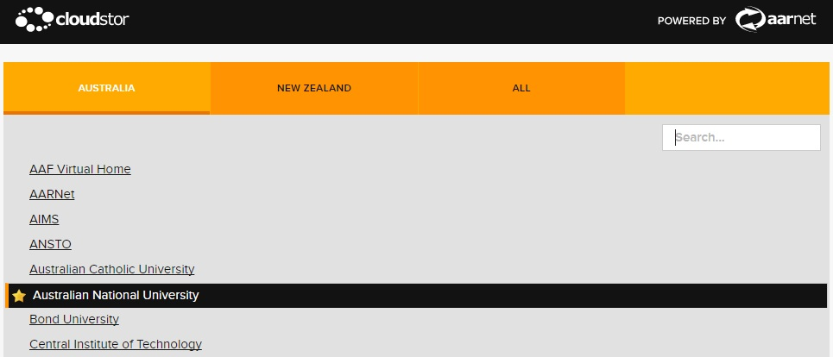
You are then asked to log in using your university ID and password:
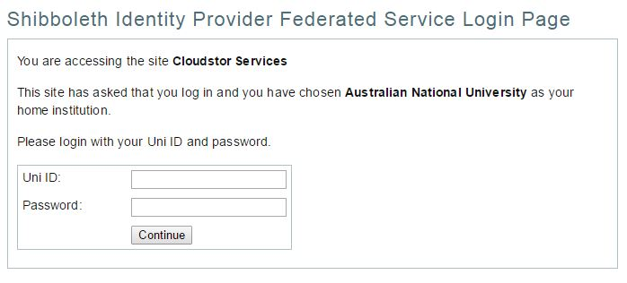

When you first log in with Cloudstor, you are given the option of downloading ownCloud.
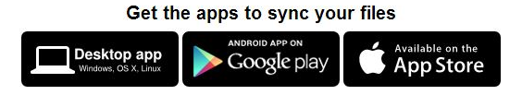
Select the Desktop app. Instructions for installing ownCloud are described in the following section.

When you see your name in the upper right-hand corner of the Cloudstor page, you know you have successfully signed in and have access to 100 Gb of free storage!
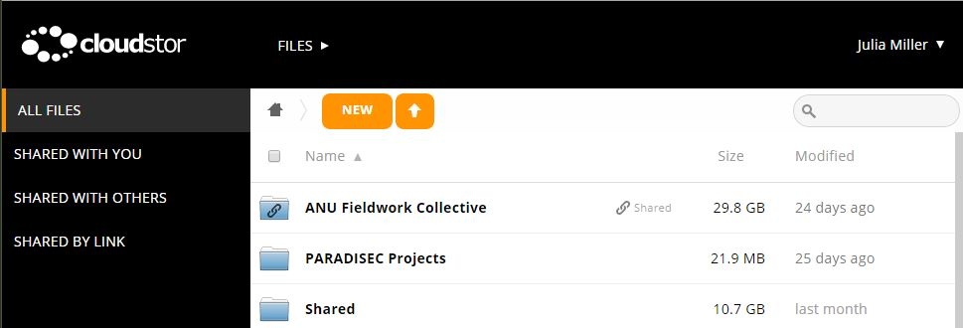
Once you have logged in, you may upload files, create folders, share files via links, or assign access by adding someone’s email. For more information, the Cloudstor user guide can be found here: https://www.aarnet.edu.au/images/uploads/resources/AARNetCloudStorManual.pdf

ownCloud
ownCloud is a 3rd party software that includes Cloudstor as one of their clients. It allows you to sync your selected files in you Cloudstor collection with your computer. To download ownCloud, go to https://owncloud.org/ and click on the Download link, if you haven’t already downloaded ownCloud during your first log-in session with Cloudstor.

Then select desktop clients:
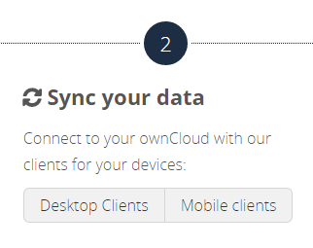
Choose which file to download based on your operating system:
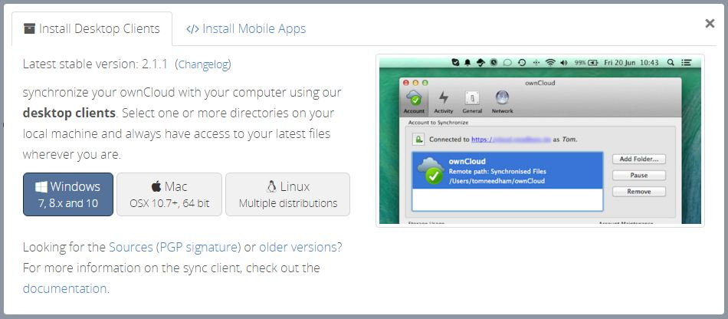
Once the wizard begins, select the standard set of components to download:
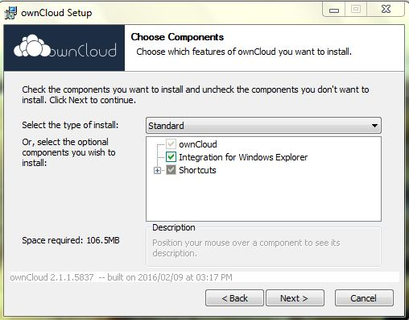
Once installation has been completed, you are prompted to start the program.

If you go to the upper right corner and click on the dropdown menu next to your name, select the personal menu and there you can find your account settings, including how to change your log-in password for ownCloud.
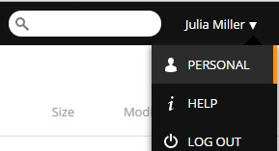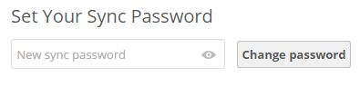

ownCloud requires you to create a separate sync password. Note that this password is not used to log into your CloudStor account. It won’t change the password you use to log into the CloudStor interface. Once you have done this, you need to create the connection to Cloudstor. When you are prompted to enter a server address, use this: https://cloudstor.aarnet.edu.au/plus
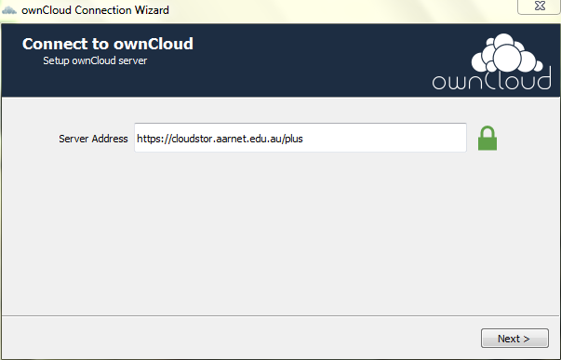
Next you enter institutional email address and the new sync password you just created (ie: not your institutional login password for CloudStor):

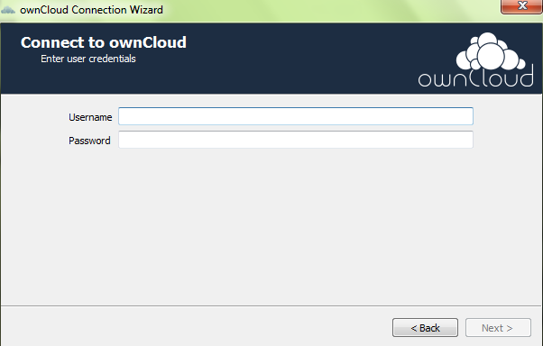

Because I know I have very large files on my Cloudtor account that will blow out my laptop’s storage I will choose which of them I want to sync:
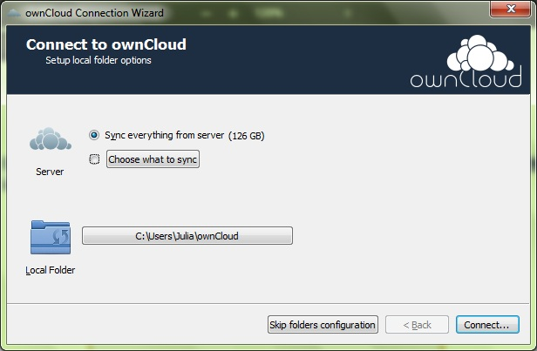
In the image above you can see the Local Folder- if you wish to change this location, click the tab and browse to your chosen location.

Tick the box next to the folder(s) you wish to sync (essentially this downloads a copy of the folder contents to your ownCloud folder on your computer.
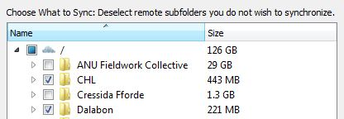
You are done! If you wish to see your files online, the top link will take you to your Cloudstor account. The bottom link takes you to your local ownCloud folder, or to simply exit, click Finish.
